Reversible And Irreversible Processes
We see so many changes happening around us every day such, as boiling of water, rusting of iron, melting ice, burning of paper, etc. In all these processes we observe that the system in consideration goes from an initial state to a final state where some amount of heat is absorbed from the surrounding and some amount of work W is done by the system on the surrounding. Now, for how many of such systems can the system and the surrounding be brought back to their initial state? With common examples such as rusting and fermentation, we can say that in most of the cases it is not possible. In this section, we shall learn about the reversible and irreversible processes.
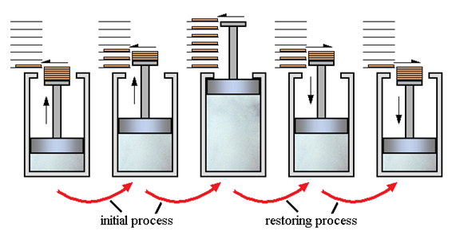
Reversible and Irreversible Processes

What are Reversible Processes?
A thermodynamic process (state i → state f ) is said to be reversible if the process can be turned back such that both the system and the surroundings return to their original states, with no other change anywhere else in the universe. As we know, in reality, no such processes as reversible processes can exist. Thus, the reversible processes can easily be defined as idealizations or models of real processes, on which the limits of the system or device are to be defined. They help us in incurring the maximum efficiency a system can provide in ideal working conditions and thus the target design that can be set.

Examples of Reversible Process
Here, we have listed a few examples of Reversible Process:
- extension of springs
- slow adiabatic compression or expansion of gases
- electrolysis (with no resistance in the electrolyte)
- the frictionless motion of solids
- slow isothermal compression or expansion of gases

What are Irreversible Processes?
An irreversible process can be defined as a process in which the system and the surroundings do not return to their original condition once the process is initiated. Taking an example of an automobile engine, that has travelled a distance with the aid of fuel equal to an amount ‘x’. During the process, the fuel burns to provide energy to the engine, converting itself into smoke and heat energy. We cannot retrieve the energy lost by the fuel and cannot get back the original form. There are many factors due to which the irreversibility of a process occurs, namely:
- The friction that converts the energy of the fuel to heat energy
- The unrestrained expansion of the fluid which prevents from regaining the original form of the fuel Heat transfer through a finite temperature, the reverse of which is not possible as the forward process, in this case, is spontaneous
- Mixing of two different substances which cannot be separated as the process of intermixing is again spontaneous in nature, the reverse of which is not feasible.
Thus, some processes are reversible while others are irreversible in nature depending upon their ability to return to their original state from their final state.

Examples of Irreversible Processes
A few examples of Irreversible Processes are:
- Relative motion with friction
- Throttling
- Heat transfer
- Diffusion
- Electricity flow through a resistance

Irreversibility, Entropy Changes, and ``Lost Work''
Consider a system in contact with a heat reservoir during a reversible process. If there is heat absorbed by the reservoir at temperature , the change in entropy of the reservoir is 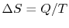 . In general, reversible processes are accompanied by heat exchanges that occur at different temperatures. To analyze these, we can visualize a sequence of heat reservoirs at different temperatures so that during any infinitesimal portion of the cycle there will not be any heat transferred over a finite temperature difference.
During any infinitesimal portion, heat 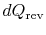 will be transferred between the system and one of the reservoirs which is at . If  is absorbed by the system, the entropy change of the system is
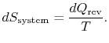
The entropy change of the reservoir is T(s)= 6000+ 273 = 6273K; T(e) = 15+273= 288K
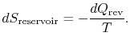
The total entropy change of system plus surroundings is
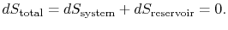
This is also true if there is a quantity of heat rejected by the system.
The conclusion is that for a reversible process, no change occurs in the total entropy produced, i.e., the entropy of the system plus the entropy of the surroundings: 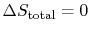 .
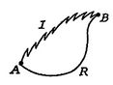
Figure 6.7: Irreversible and reversible state changes
We now carry out the same type of analysis for an irreversible process, which takes the system between the same specified states as in the reversible process. This is shown schematically in Figure 6.7, with and denoting the irreversible and reversible processes. In the irreversible process, the system receives heat and does work . The change in internal energy for the irreversible process is
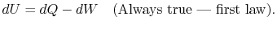
For the reversible process
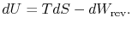
Because the state change is the same in the two processes (we specified that it was), the change in internal energy is the same. Equating the changes in internal energy in the above two expressions yields
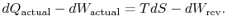
The subscript ``actual'' refers to the actual process (which is irreversible). The entropy change associated with the state change is
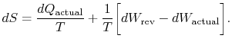 | (6..3)

If the process is not reversible, we obtain less work (see IAW notes) than in a reversible process, 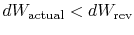 , so that for the irreversible process,
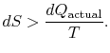
There is no equality between the entropy change and the quantity 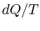 for an irreversible process. The equality is only applicable for a reversible process. 
The change in entropy for any process that leads to a transformation between an initial state ``a'' and a final state ``b'' is therefore
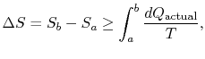
where, 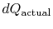 is the heat exchanged in the actual process. The equality only applies to a reversible process.
The difference 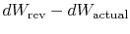 represents work we could have obtained, but did not. It is referred to as lost work and denoted by 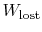 . In terms of this quantity we can write,
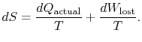 | (6..4)

The content of Equation (6.4) is that the entropy of a system can be altered in two ways: (i) through heat exchange and (ii) through irreversibilities. The lost work ( 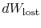 in Equation (6.4)) is always greater than zero, so the only way to decrease the entropy of a system is through heat transfer.
To apply the second law we consider the total entropy change (system plus surroundings). If the surroundings are a reservoir at temperature , with which the system exchanges heat,
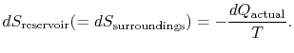
The total entropy change is
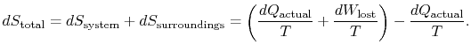
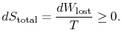
The quantity ( 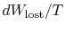 ) is the entropy generated due to irreversibility.
Yet another way to state the distinction we are making is
(6..5)

The lost work is also called dissipation and noted . Using this notation, the infinitesimal entropy change of the system becomes:
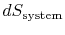 | 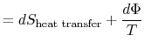
or

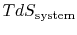 | 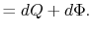

Equation (6.5) can also be written as a rate equation,
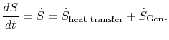 | (6..6)

Either of Equation (6.5) or (6.6) can be interpreted to mean that the entropy of the system, , is affected by two factors: the flow of heat and the appearance of additional entropy, denoted by 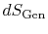 , due to irreversibility^{6.1}. This additional entropy is zero when the process is reversible and always positive when the process is irreversible. Thus, one can say that the system develops sources which create entropy during an irreversible process. The second law asserts that sinks of entropy are impossible in nature, which is a more graphic way of saying that  and 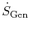 are positive definite (always greater than zero), or zero in the special case of reversible processes.
The term
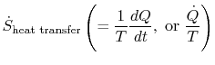
which is associated with heat transfer to the system, can be interpreted as a flux of entropy. The boundary is crossed by heat and the ratio of this heat flux to temperature can be defined as a flux of entropy. There are no restrictions on the sign of this quantity, and we can say that this flux either contributes towards, or drains away, the system's entropy. During a reversible process, only this flux can affect the entropy of the system. This terminology suggests that we interpret entropy as a kind of weightless fluid, whose quantity is conserved (like that of matter) during a reversible process. During an irreversible process, however, this fluid is not conserved; it cannot disappear, but rather is created by sources throughout the system. While this interpretation should not be taken too literally, it provides an easy mode of expression and is in the same category of concepts such as those associated with the phrases ``flux of energy'' or ``sources of heat.'' In fluid mechanics, for example, this graphic language is very effective and there should be no objections to copying it in thermodynamics.
Change of entropy in irreversible processes

So far we have been considering the change of entropy only in reversible-processes. Let us turn now to the problem associated with the change of entropy in irreversible processes and, in particular, in irreversible processes proceeding in an isolated system, which are of the greatest interest. Isolated is the name given to a system with a rigid boundary with ideal heat insulation. The ideal heat insulation prevents any heat exchange between the system and the surroundings (dQ_{sys} = 0), and the rigid boundary protects the system against any exchange of expansion work with the surroundings. Sine dQ_{sys} = 0 and p dV_{sys} = 0, it is clear from Eq. (2.37a) that dU_{sys} = 0, i.e. U_{sys} = const. The analysis of the processes proceeding in an isolated system is of interest mostly because in the limit any non-isolated system and its surroundings can be treated as an integral isolated system.
Inasmuch as for an isolated system dQ_{sys} = 0, any process proceeding in such a system is an adiabatic process for the system as a whole.
Consider an isolated system comprising two bodies at different temperatures T₁ and T₂ with T₁ > T₂. Heat transfer will take place between these bodies of the system; heat will flow from the body at the higher temperature T₁ to the body at the lower temperature T₂. If an amount of heat dQ flows from the first body to the second, consequently, in accordance with Eq. (3.115), the entropy of the first body will be reduced by

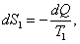 (3.130)

and the entropy of the second body will increase by

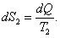 (3.131)

It is clear that the total change in the entropy of the entire system is

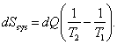 (3.132)

Since

we have

(3.133)

i.e. an irreversible process results in an increase in the entropy of an isolated system.
If the process of heat transfer between the component parts of the system was reversible (it will be recalled that the condition for the reversibility of a process is an infinitesimal temperature difference T₁ - T₂ = dT), the entropy of the first body would diminish by



and the entropy of the second body would increase by

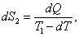

so that for the system as a whole the change in entropy would he negligibly small:

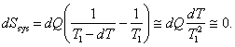 (3.134)

Another method of reversible heat transfer from a body at a higher temperature to a body at a lower temperature involves, as already mentioned, the Carnot cycle. To realize any irreversible cycle, a system consisting of three elements out of equilibrium - a high-temperature heat source, a low-temperature heat sink, and a working medium - must be available. If during one cycle heat Q₁ is removed from the high-temperature heat source (at temperature T₁) and heat Q₂ is added to the low-temperature heat sink (at temperature T₂), the entropy of the high-temperature heat source will diminish by

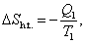 (3.135)

and the entropy of the low-temperature sink will increase by

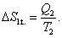 (3.136)

As regards the entropy of the working medium, since upon completion of the cycle the working medium returns into its initial state, its entropy does not change:

(3.137)

Hence, after a system undergoes a cycle the change in the entropy of the system considered is equal to

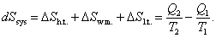 (3.138)

Equation (3.138) is true for any reversible and irreversible cycles operated between two heat sources (a source and a sink).
As was shown above, for a reversible Carnot cycle,

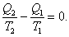

Hence, if a reversible Carnot cycle is realized in a system (or any other cycle is accomplished between a heat source and a heat sink), the entropy of the system does not change:

(3.139)

At what temperature ⁰C and ⁰F HAS THE SAME VALUE?

C/5 = (F-32)/9
C= F = -40⁰

